Yum install git

Git –version

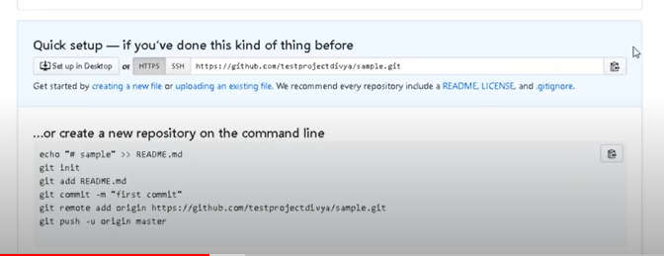

Git clone #id

Ls

(you can see the repo name)

cd #repo

to create a new file in redhat:  
touch text1 (creates a new file named text1)

git add .

git commit -m “message”

git push origin master

**if git asks for credentials every time we push:**

git config credential.helper store

git push #repo_id